Home Work MongoDB DML - Roman Sokolov 04.11.2021

1. db. animals.save({_id:1});
db. animals.find();
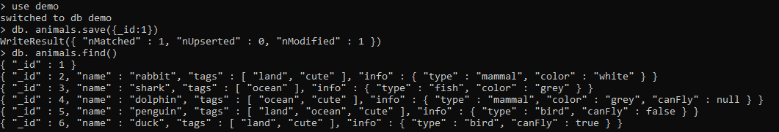

2. db.animals.insert({_id : 1 }); //failed
db.animals.save({_id : 1});//success
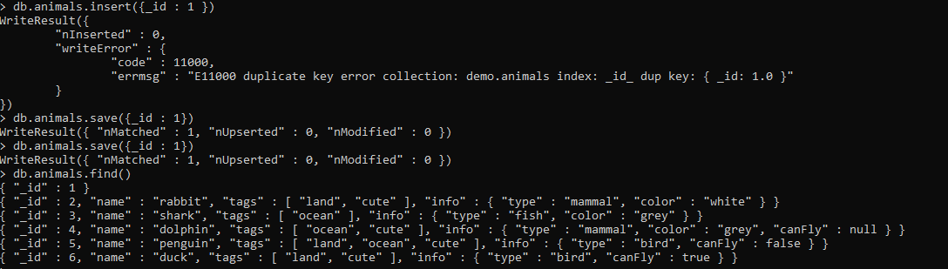

3. db.animals.updateOne({_id : 1 } , {$set : { name : "lion"}});
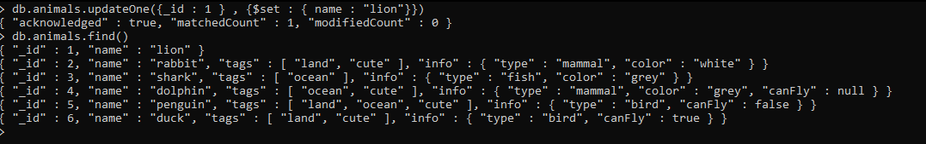

db.animals.findAndModify({query:{_id:1}, update:{$set:{ Name : "lion" }}});

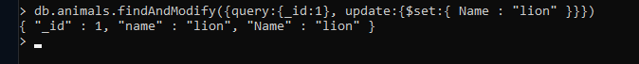

4. db.animals.findAndModify({query:{_id:1}, update:{$set:{Age:30}}});

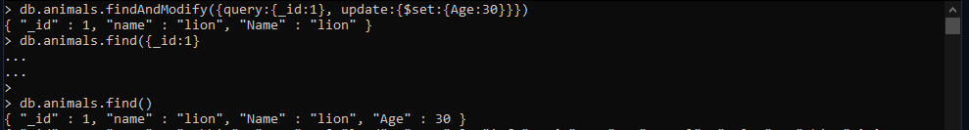

db. animals.updateOne( {_id:1}, {$set:{age:30} } );
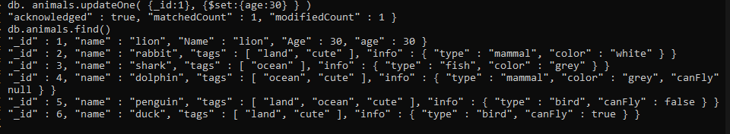
5. db.animals.updateOne ( {_id:1} , { $inc : {Age :2} });
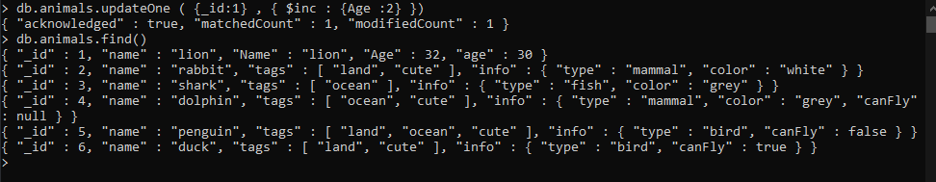

6. db.animals.updateOne ( {_id:1} , { $inc : {Age :-4} });
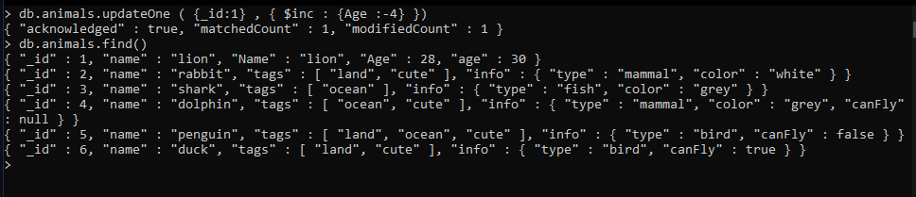

7. db.animals.updateOne( {Age:{$lt : 38} }, { $inc : {Age :2} }) // run multiple times
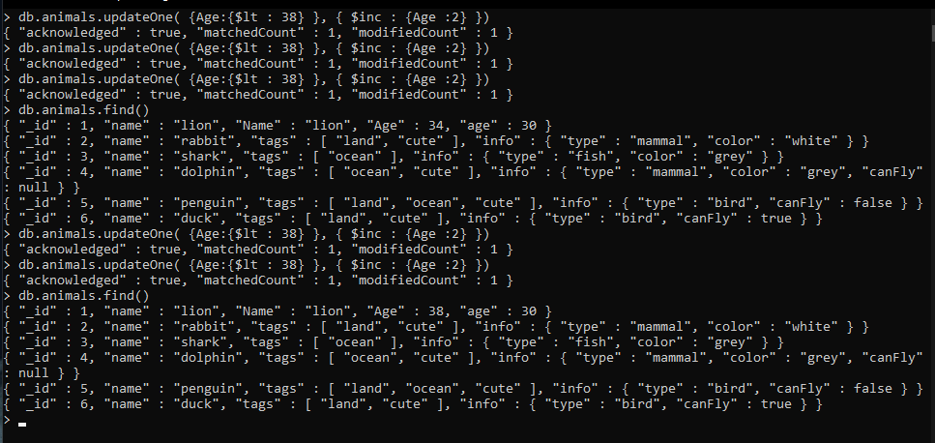

8. db.animals.update({_id : 1 } , {$mul :{"age" : 10}} )
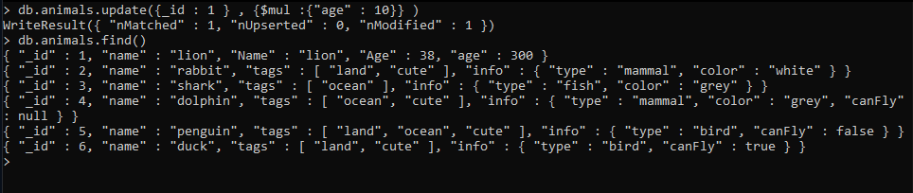

9. db. animals.updateOne( {_id:1}, {$set:{tags: ["cute"] }} );
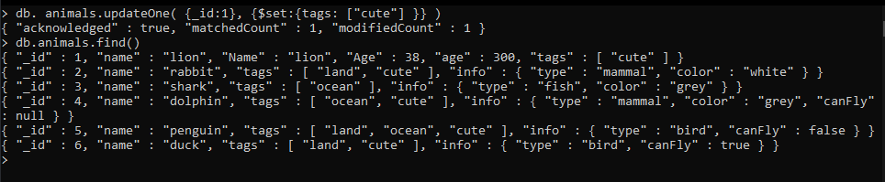

10. db.animals.updateOne( {_id:1}, {$addToSet : {tags :"Great"} })
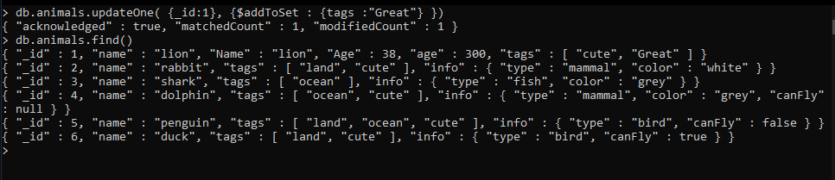

11. db.animals.updateOne({_id : 1} , {$unset :{"age" : ""}} )
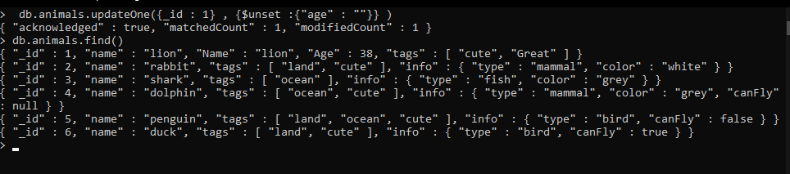

12. db.animals.updateOne( {_id:1}, {$addToSet : { tags: {$each : ["King" , "Predator"] }} })
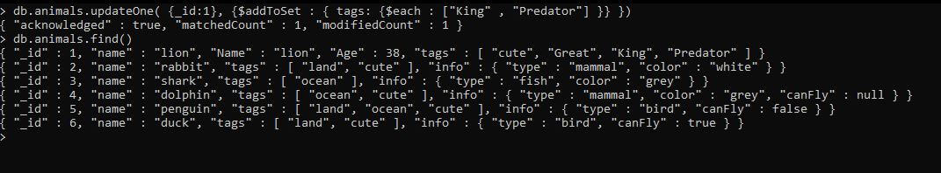

13. db.animals.updateOne({_id:1},{$addToSet: {tags:{$each["King" , "Predator"] , $position : 2} }})

$position is only supported for '$push' , not for '$addToSet'

14. db.animals.updateOne({_id:1},{$push : {tags:{$each : ["King" , "Predator"] , $position : 2} }})
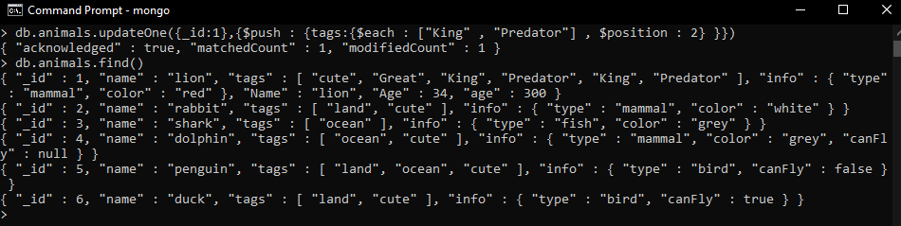

15. db.animals.updateOne( {_id:1}, {$push : {tags:{$each:["King" , "Predator" ] } })

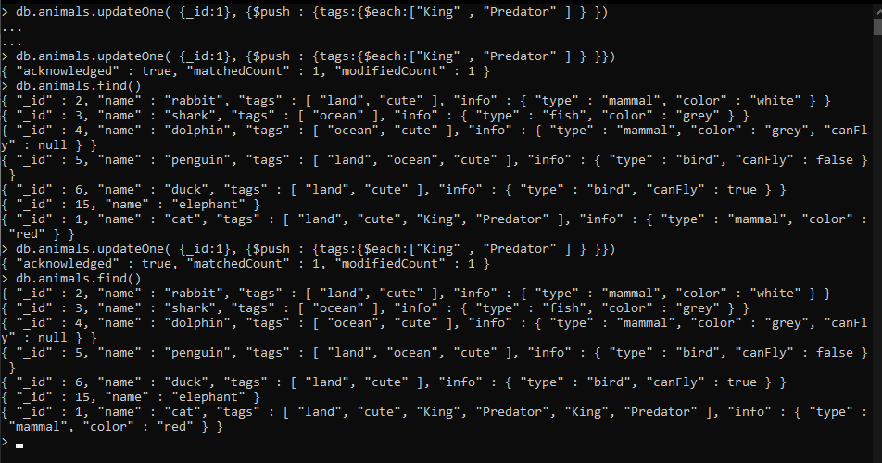

16. db.animals.updateOne( {_id:1}, {$pull: { tags :{$in : ["Great" , "King" ]} }} )

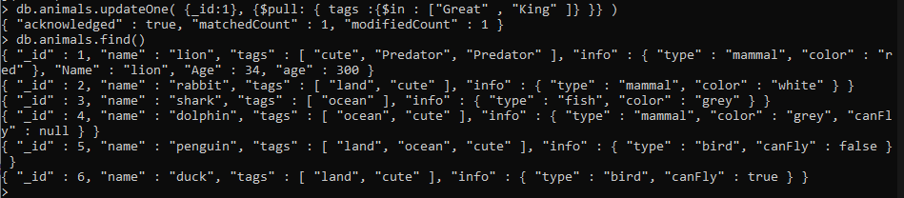

17. db.animals.updateOne( {_id:1 , tags : "cute" }, { $set: { tags : "not Cute"}})
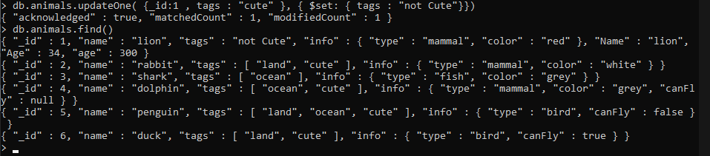

18. db.animals.updateMany( {_id:2}, { $pop: {tags : -1} })
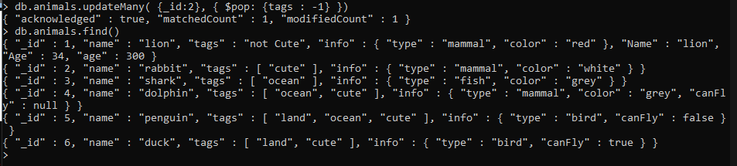

19. var i = 10 ; while(i<=20){ db.animals.save({_id : i , name: "no name" }); i++;}
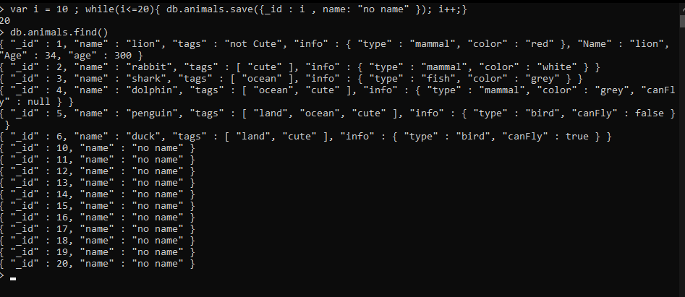

20. db.animals.updateMany({_id:{$gte:10 , $lte:20}} , {$set: {"info.color" :"grey"}} )
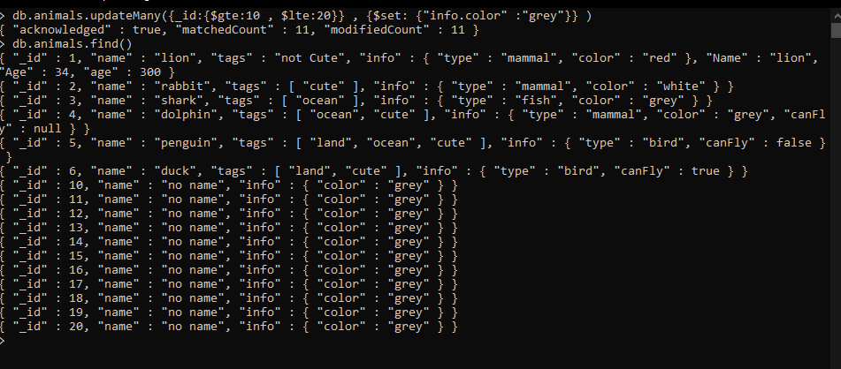

21. db.animals.updateOne ({_id:{$eq : 4 } } , {$pop : {tags : -1}})

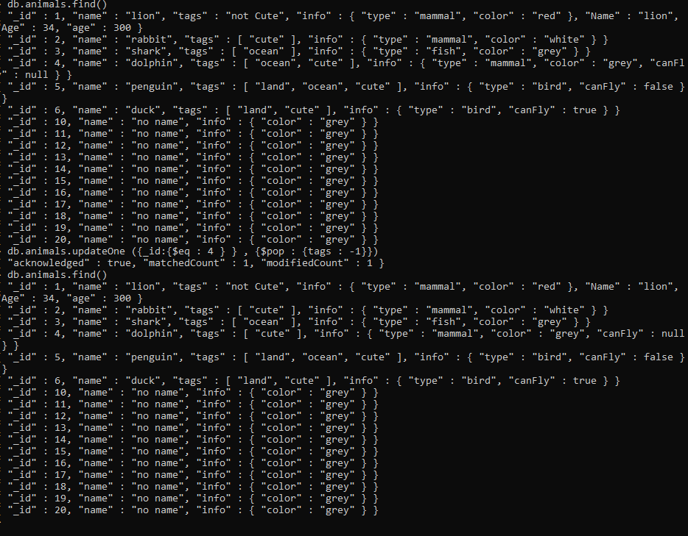

22. db.animals.updateOne ({_id:{$eq :4 } } , {$unset : {"tags" : 1}})
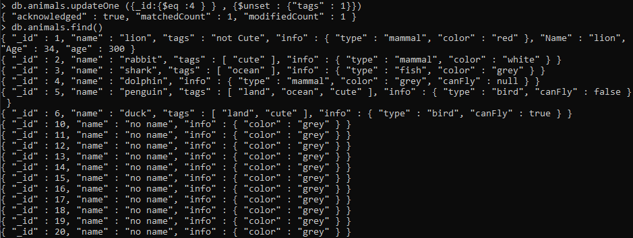

23. db.animals.deleteMany({_id: {$gte:10 , $lte:20}});

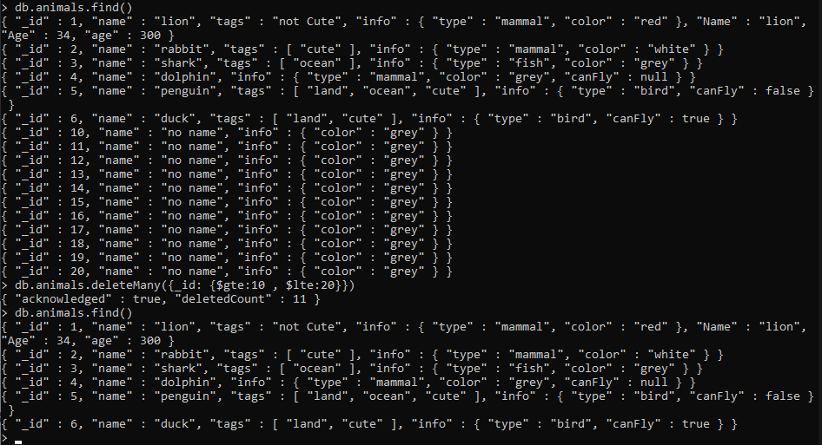

24. db.animals.updateMany({} , {$push : {tags: {"animal" }})

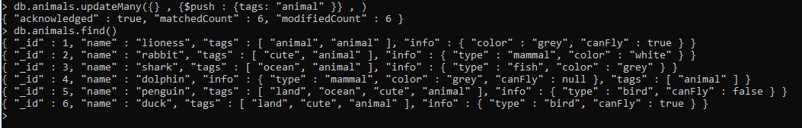

25. db.animals.replaceOne({_id : 1} , {"name" : "lioness" , "tags": ["animal"] , "info" : { "color":"grey" , "canFly" : true}} )
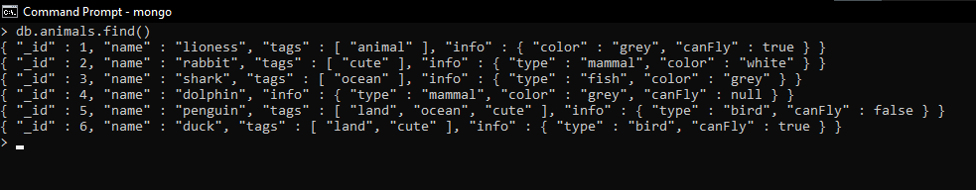

26. db.animals.updateOne({_id:15},{$set:{name:"elephant"}},{"upsert":true})
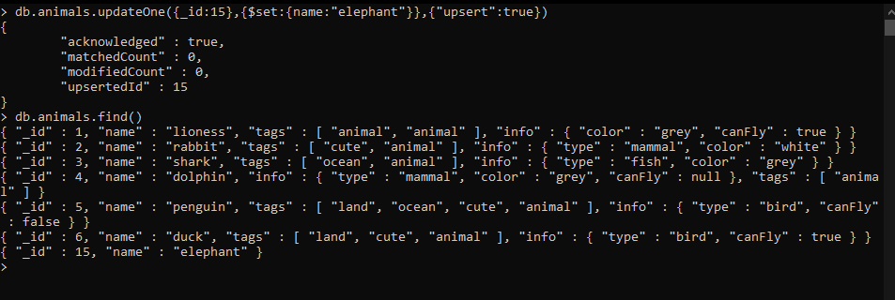

  - db.animals.bulkWrite( [ {"updateOne" : {"filter" : {"_id" : 2} ,"update" :{"name" : {$set: "dfgdfgdfgdfg" } } } } , {"deleteOne": {"filter" : {"_id" : 1}}} ] , {"ordered" : true} )
